Sarah Fox  
Homework 5 Gradle Build Tool Project

Unit Test for Surface Area of Cone Object

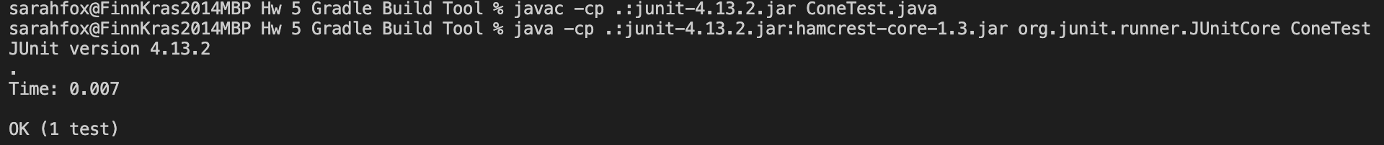

Unit Test for Volume of Cylinder Object

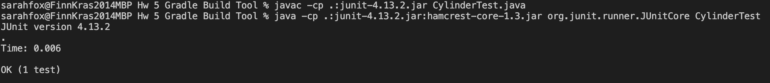

Unit Test for Volume of Sphere Object

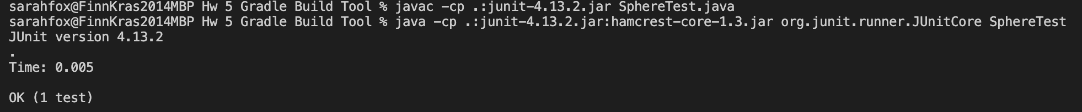

Working Main Menu from Geometry Class

**Gradle Build:**

**Gradle Run:**

**Gradle Test:**

